

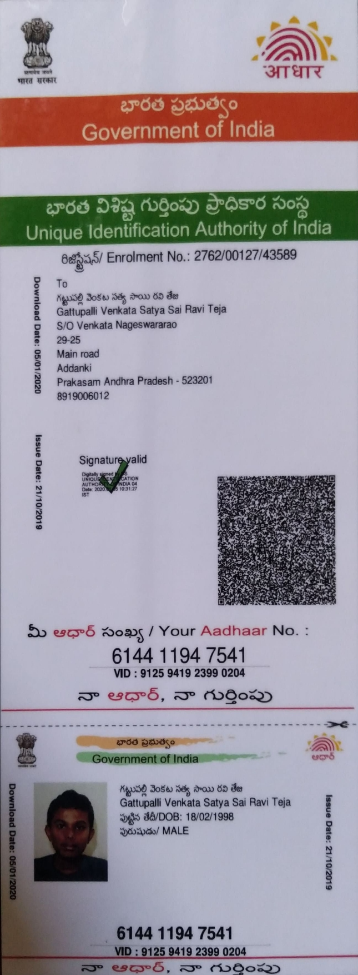

Video Link : https://methodhubindia-my.sharepoint.com/:v:/g/personal/sudha_vilvanathan_method-hub_com/EZ8OaeJ-pGxGkqpiIIkG7b0BDRnUQx11WdXBDVhM32696Q

RaviTeja Gattupalli Email:gattupalliravi1@gmail.com
Linkedin:https://www.linkedin.com/in/raviteja-gattupalli-4675b8221/ Mobile: 8919006012

Education

- R.V.R & J.C COLLEGE OF ENGINEERING April 2016-May 2020 B.Tech in Information Technology, GPA:9.2

Skills Summary
- Languages: Python, Scala,SQL
- Big Data Technologies: Hadoop Architecture ,Spark,Hive,Hbase
- Tools: GIT,JIRA,SQL-Data-Compare,Jenkins
- Cloud Platforms: Databricks, Aws(Glue,s3,Lambda,Ec2,Redshift) , Azure(ADF,Blob storage,synapse Analytics)
- Orchestration Tool: Airflow

Professional Certifications

- Databricks Data Engineer Associate Issued on 27-08-23
- Data Structures and SQL on NPTEL Issued on 21-10-21

Work Experience
- FactSet Research Systems Hyderabad
Software Engineer-III Nov 2021-Current

  - Standard DataFeed: Played a vital role in enhancing and upholding the excellence of FactSet's flagship product, SDF (Standard Data Feeds). Took charge of key responsibilities involving the curation of data from diverse sources within the FactSet ecosystem. Successfully executed complex data transformations, ensuring a unified client experience that catered to a
substantial customer base exceeding 10,000 across multiple data feeds. Leveraged the
capabilities of Apache Spark on an AWS EMR Hadoop cluster to expertly execute this intricate data orchestration

  - Rule Based Transformations: Designed and implemented a rule-based data processing project, successfully automating diverse data operations using JSON-formatted rules.
Developed and implemented functionalities for downloading, cleaning, filtering, removing duplicates ,Pivoting,grouping, eliminating null values etc... Leveraged Glue jobs to execute the defined rules, resulting in efficient and streamlined data processing

  - Delta Sync: Led implementation of Databricks Delta tables, enabling efficient Change Data Capture (CDC) for streamlined data ingestion. Orchestrated recurring workflows to process
delta updates, handling upserts and deletes effectively. Additionally, developed an asynchronous API that leverages table names and timestamps to retrieve updates from Delta tables and provide clients with notifications and relevant filenames.

- Meta Apis : Developed the APIs to retrieve diverse metadata insights for clients,
encompassing subscribed bundles and file updates. Developed this robust system using AWS Lambda and Flask, offering real-time access to crucial information such as subscribed bundles per client and the presence of new files within specific bundles ,etc.

- OnCall -Curator: served as a responsible on-call curator for the product to resolve any fails in the daily complex database update systems, Engaged in ticket-based solutions to rectify
client-facing issues in the existing system, ensuring seamless functionality and user satisfaction.

- Fission Labs Hyderabad
Associate Software Engineer Nov 2020-Nov 2021

- Automated Linux Administration Tasks:Spearheaded the automation of key Linux
administrative tasks, including proactive responses to server thresholds (CPU, memory, disk) and streamlined processes for user management within Active Directory, encompassing user creation and password resets

- Ticketing Data Analysis : Managed end-to-end project handling ticketing data processing and processing according to business needs , and seamless integration of information into
HBase database, meeting dynamic business requirements

